Open win registory editor using run>regedit

Go to Computer\HKEY_LOCAL_MACHINE\SYSTEM\CurrentControlSet\Control\ and create new key

Name this key “StorageDevicePolicies”

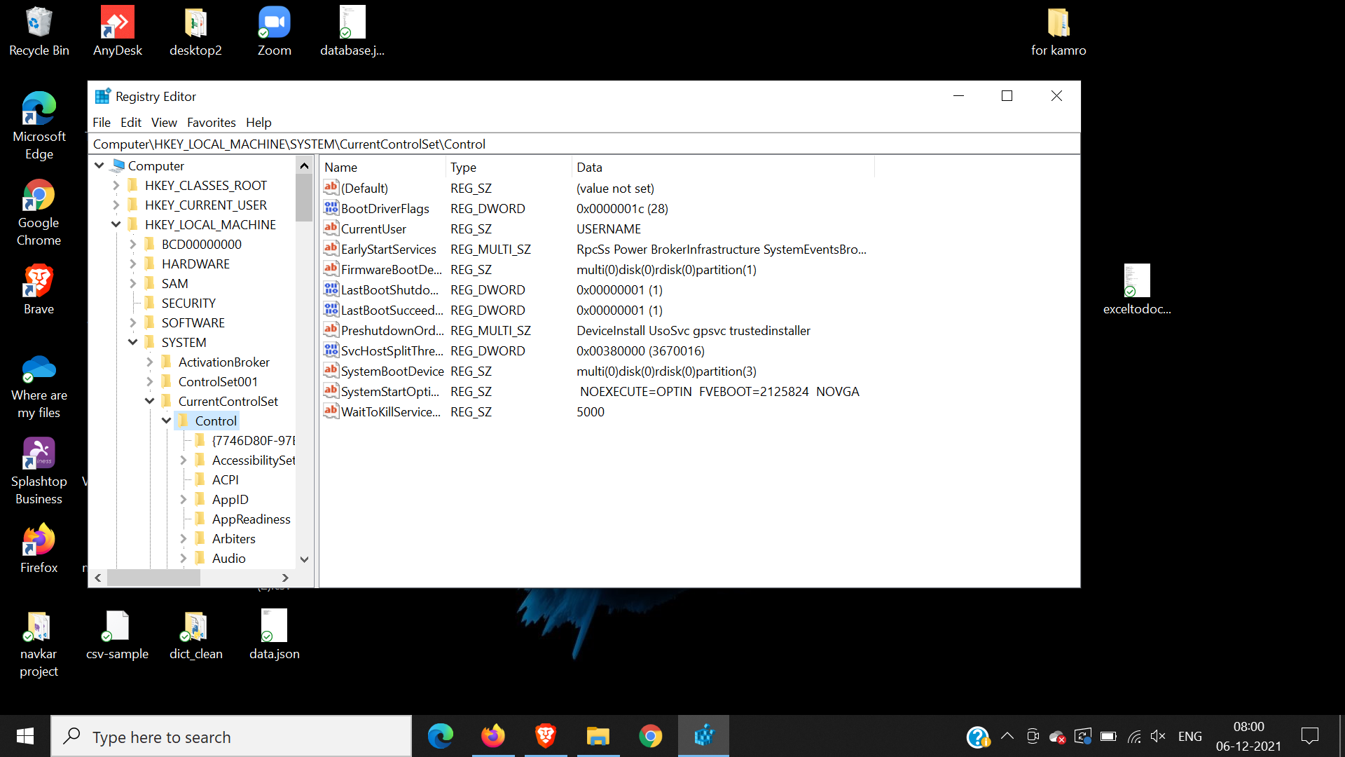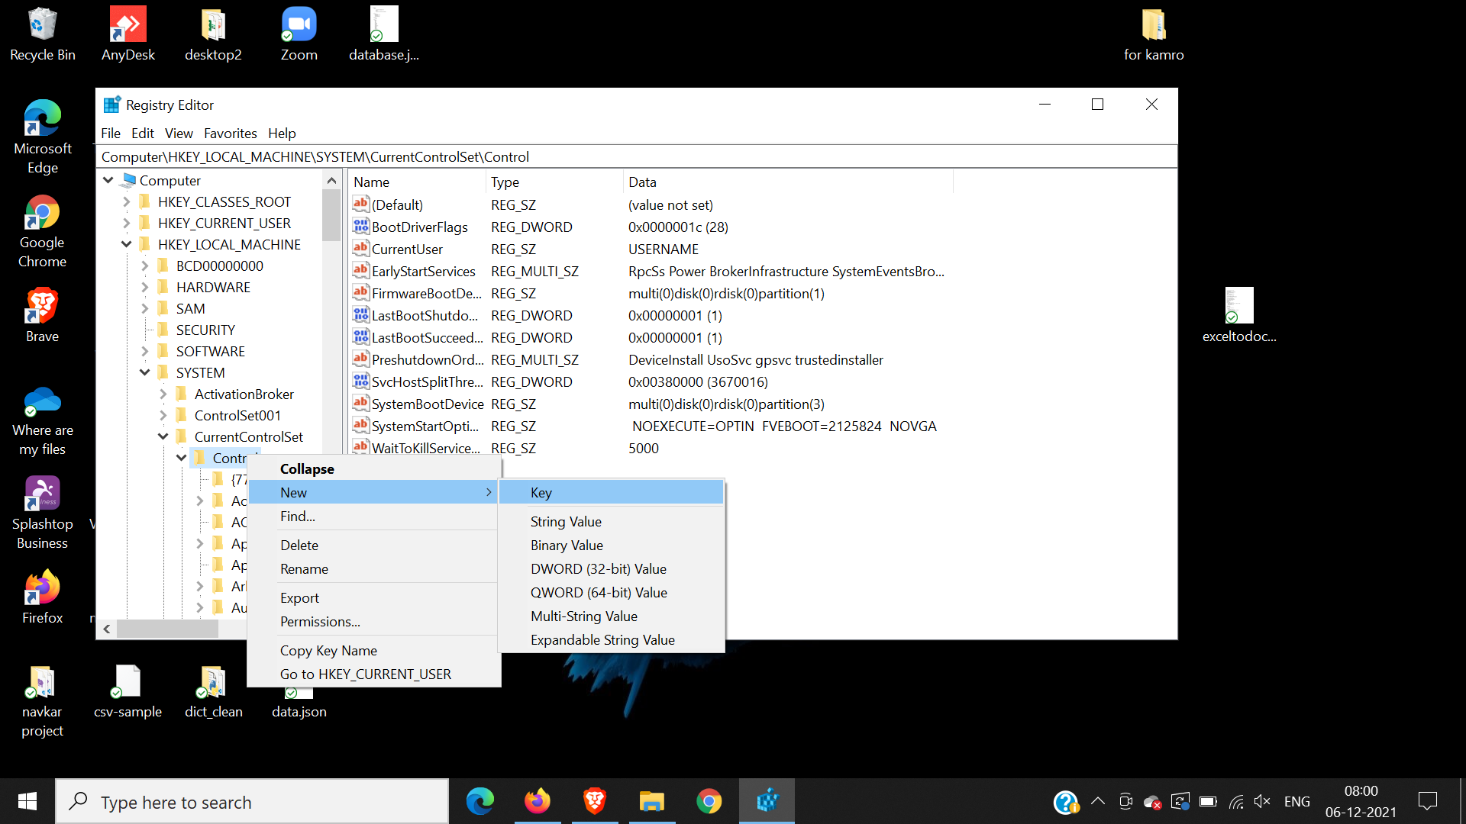

Make New Dword name it “WriteProtect”

Enter Hexa value as 1

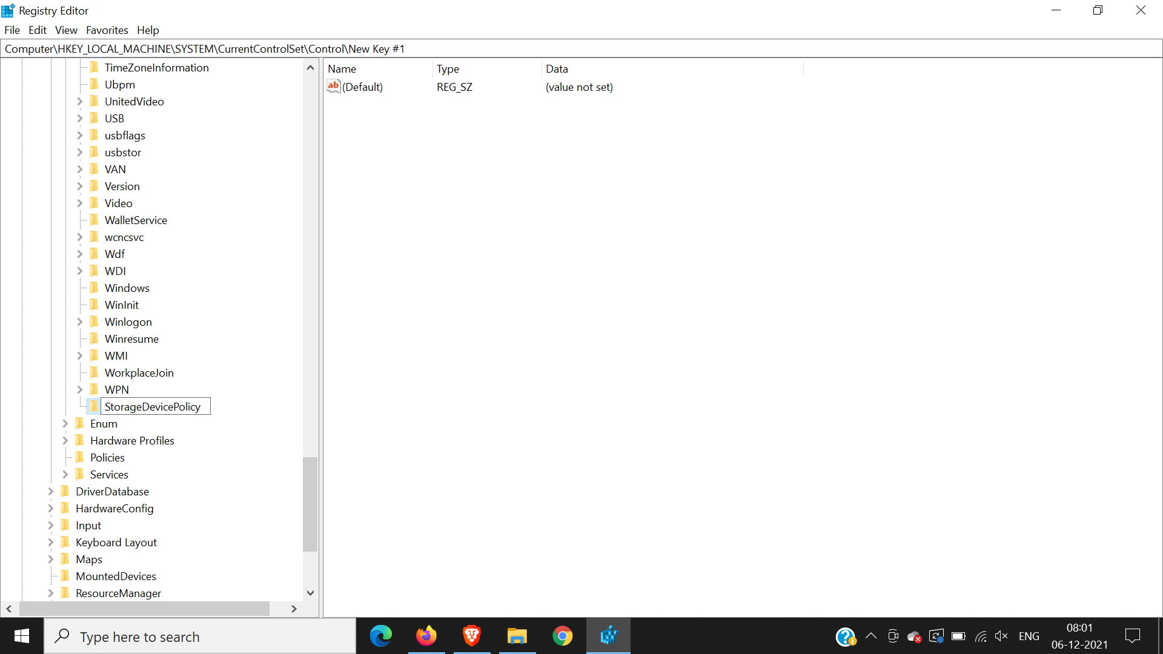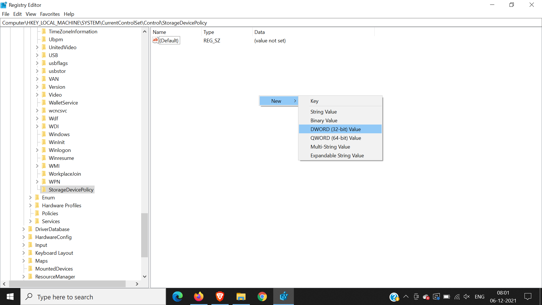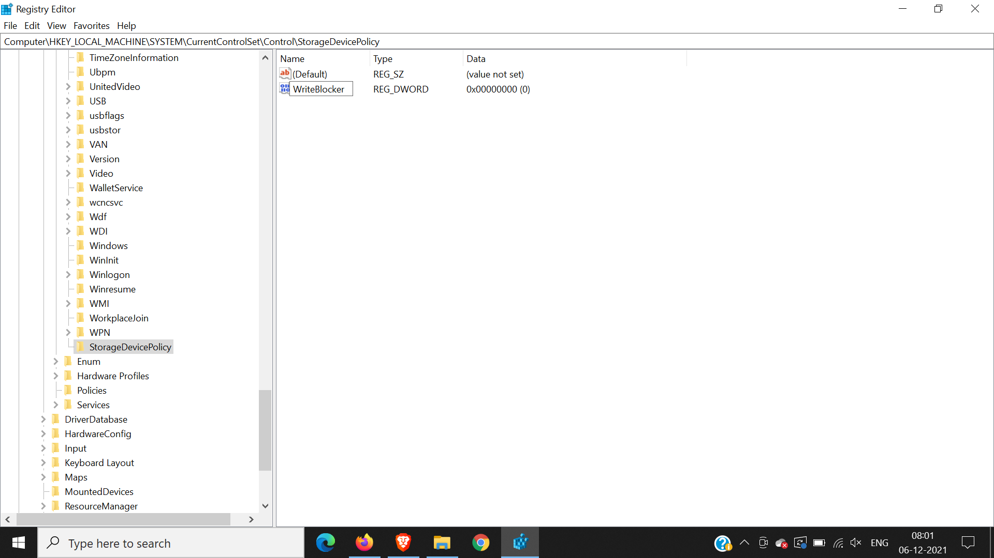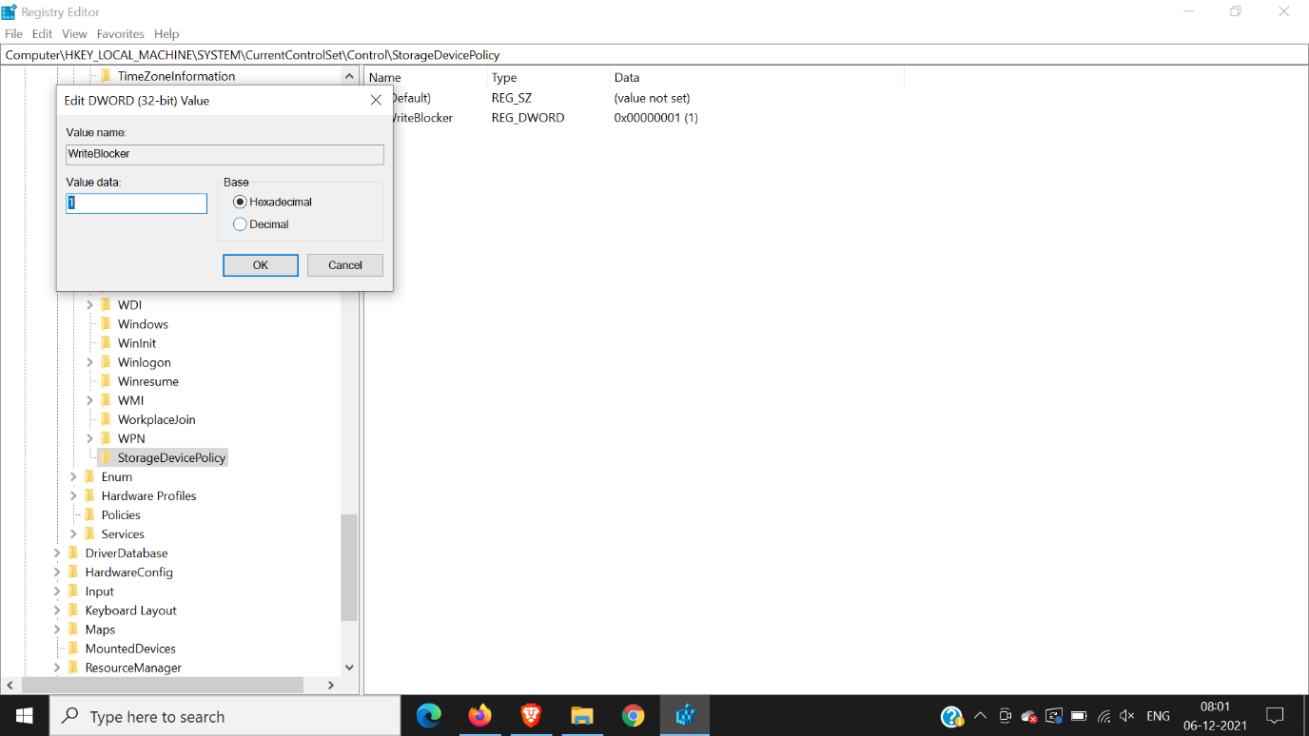

THE SPELLING IS VERY IMPORTANT RENAME IF YOU ENTERED WRONG

“StorageDevicePolicies”

“WriteProtect”

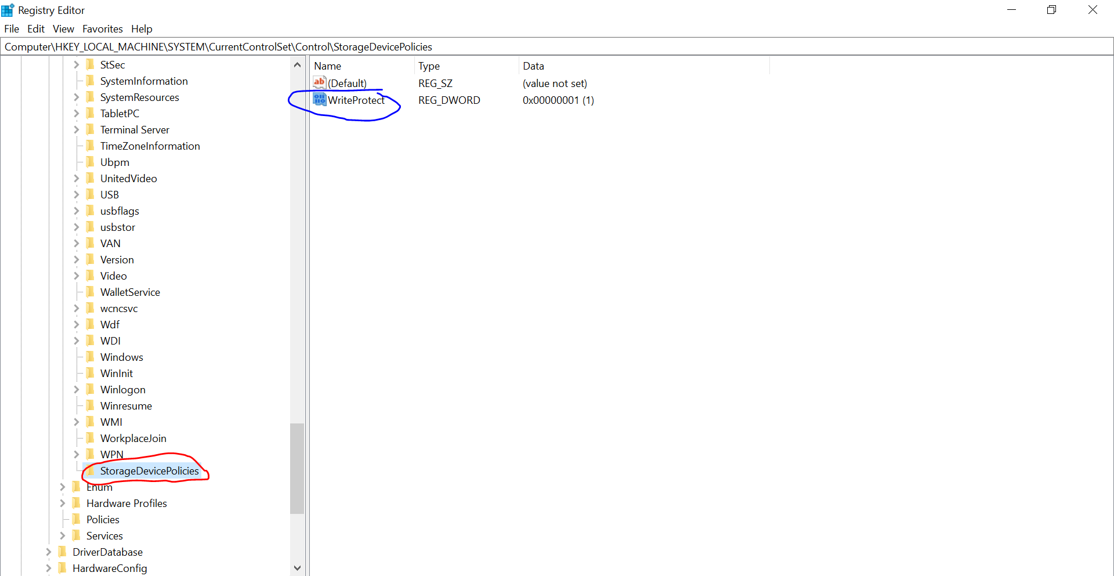

We can only open the file in the USB drive for reading, but it’s not allowed to modify and

save the changes back to USB drive.

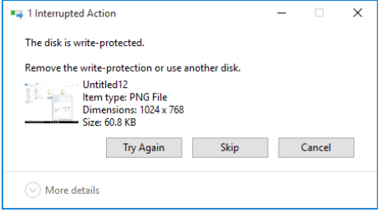

Now Create image of the USB drive using FTK imager

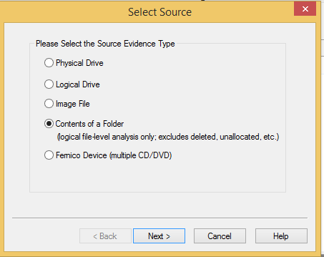

**Enter data into the required fields. Select the destination folder.**

**Image file is created and you can verify it.**

